 CHEMICAL ENGINEERING TRANSACTIONS  VOL. xxx, 2026 | A publication of  
The Italian Association
of Chemical Engineering
Online at www.cetjournal.it

Guest Editors: Flavio Manenti, Botir Usmonov, Alessandro Di Pretoro
Copyright © 2026, AIDIC Servizi S.r.l.
ISBN 979-12-81206-xx-x; ISSN 2283-9216
Electrochemical CO₂ recycling demonstration plant: Design and commissioning of carbon capture and electrochemical CO₂ conversion in a cement plant
Jose Antonio Abarca, Javier Zorrilla, Lucía Gómez-Coma, Guillermo Díaz-Sainz, Angel Irabien
Departamento de Ingenierías Química y Biomolecular, Universidad de Cantabria, Av. de los Castros s/n, 39005 Santander, España

Abstract
This study presents the design, experimental validation, and integration of a CO₂ capture and utilization demonstration plant aimed at industrial decarbonization, with particular focus on cement plant exhaust gases. A membrane‑based capture unit employing polymeric hollow‑fiber modules enriches CO₂ from flue gas streams containing 7–15% v/v CO₂ up to concentrations exceeding 95%. The captured CO₂ is subsequently converted to formate via electrochemical CO₂ reduction (ERCO₂) in a laboratory‑scale electrolyzer operating with a 100 cm² gas diffusion electrode based on (BiO)₂CO₃. Stable long‑term operation is demonstrated over 12 consecutive days, achieving initial Faradaic efficiencies (FE) for formate close to 100% and maintaining ~75% after prolonged testing, with cumulative production exceeding 20 mol. Experimental datasets are used to develop predictive models for both capture and conversion stages, which are integrated into a digital twin capable of accurately predicting system performance (R² ≈ 0.99 for key variables). Based on these results, an integrated pilot plant treating up to 20 L·min⁻¹ of a concentrated CO₂ stream and employing a total electrochemical active area of 1000 cm² is proposed, supporting the feasibility of scaling CCU technologies for industrial deployment.
  - Introduction
In the current global context of increasing atmospheric CO₂ emissions caused by human activities, it is essential to adopt effective mitigation strategies in order to prevent the adverse effects of climate change and global warming. To this end, numerous approaches aim to promote the decarbonization of society, including the deployment of renewable energy sources, the electrification of industrial processes, and improvements in energy efficiency. However, several industrial sectors, most notably the cement, chemical, and aviation industries, remain difficult to abate and require additional decarbonization strategies (Rafiee et al., 2018).
This decarbonization pathway generally consists of two main steps. In the first step, CO₂ is recovered from industrial off-gas streams. In the subsequent step, the captured CO₂ is upgraded into value‑added chemical products. To enable efficient separation of CO₂ from flue gases and to avoid its emission into the atmosphere, a variety of capture technologies have been well studied. These include absorption-based processes, adsorption on solid materials, membrane separation systems, and cryogenic methods (Mikulčić et al. 2019). Among the available capture options, membrane-based separation has attracted considerable interest owing to its compact footprint, low energy requirements, operational simplicity, and improved selectivity characteristics (He et al., 2015). Furthermore, the inherent modularity of membrane systems facilitates straightforward scaling, reinforcing their potential for large-scale industrial CO₂ capture. In particular, polymeric membranes are well suited for post-combustion separation, as they can efficiently discriminate CO₂ from the main components of flue gas streams, which primarily consist of CO₂, N₂, O₂, and minor amounts of CO or NOₓ (Han and Ho, 2021).
After capture, CO₂ is fed into the conversion stage. Within this framework, the electrochemical reduction of CO₂ (ERCO₂) to value‑added products has emerged as one of the most promising conversion pathways, offering both economic and environmental advantages (Rumayor et al. 2019). At the laboratory scale, this technology has achieved remarkable progress, including high Faradaic efficiencies (FE) toward formate and the generation of products at elevated concentrations. In light of these developments, it is timely to consider the progression toward larger‑scale implementation. Notably, several key intermediate milestones have been attained, such as the successful testing of prototypes with active areas ranging from 100 to 300 cm² under controlled laboratory conditions. These achievements support the feasibility of advancing toward an industrial‑scale demonstration unit integrated into real industrial environments, such as cement manufacturing facilities (Abarca et al. 2026).
Accordingly, this study proposes the direct coupling of a cement plant’s combustion exhaust line with an integrated CO₂ recycling system. The proposed configuration comprises a CO₂ capture unit that supplies purified CO₂ to a downstream electrochemical conversion module. The overall system is designed to handle a CO₂ flow rate of 20 L·min⁻¹, employing an electrochemical reactor with a total active area of 1000 cm².
The initial phase focuses on defining the technical requirements for linking the CO₂ recycling facility to the cement plant exhaust stack. For this purpose, gas samples are taken from the target industry and analyzed, revealing CO₂ concentrations reaching values of up to 15%. These measurements confirm the necessity of incorporating a dedicated CO₂ capture stage before electrochemical conversion. To meet this requirement, a membrane-based CO₂ capture unit is selected, capable of enriching the CO₂ stream to concentrations exceeding 95%, thus providing a suitable feed for the subsequent conversion process. The electrochemical conversion section is composed of multiple reactor modules to process a total flow rate of 20 L·min⁻¹ of CO₂.
Following the definition of the installation layout, future efforts will focus on the detailed engineering, construction, and on-site validation of the integrated connection between the CO₂ capture and utilization stages. Simultaneously, a comprehensive process model will be developed to generate a digital twin of the system, enabling predictive control, automation, and optimization of plant operation.
  - Methodology
The experimental validation of the designed CO₂ capture and conversion prototypes is carried out in a laboratory-scale pilot plant. This approach allows for a thorough assessment of their operational performance before the overall design and implementation of the integrated CO₂ recycling facility.
    - Membrane-based CO₂ capture pilot plant
The membrane‑based CO₂ capture pilot plant consists of two hollow‑fiber membrane modules made of silicone (polydimethylsiloxane, PDMS)) connected in parallel (PDMSXA-7500). The modules are operated under high feed pressure, up to 3 bar, to promote selective separation, producing a CO₂‑enriched stream in the permeate, while N₂ and O₂ are predominantly retained and discharged in the retentate stream.
The installation is equipped with mass flow controllers to regulate the gas flow, as well as pressure sensors and control valves that allow precise adjustment of the feed pressure applied to the membrane modules, thereby enabling selective CO₂ separation. In addition, a gas analyzer is installed to continuously monitor the CO₂ concentration at both the inlet and outlet of the membrane modules.
    - ERCO₂ to formate pilot plant
The 100 cm² electrolyzer is integrated into a laboratory-scale pilot plant (Figure 1) designed to ensure efficient operation and enable automated data acquisition, which is essential for the development of a digital twin. The installation includes a CO₂ (or feed‑gas) mass flow controller, pumps and reservoirs for electrolyte circulation, a power supply capable of delivering currents of up to 20 A, and a gas analyzer for monitoring the composition of both the inlet and outlet streams of the electrolyzer. Additionally, the system is equipped with sensors for flow rate, conductivity, and temperature, all of which are connected to a centralized data acquisition platform that enables real‑time monitoring and control of operating conditions.
The electrolyzer operates using a gas diffusion electrode (GDE) incorporating (BiO)₂CO₃ as the catalyst, with a catalyst loading of 0.75 mg·cm⁻². The system is operated in liquid phase, employing a 1 M KCl solution as the catholyte and a 1.5 M KOH solution as the anolyte, with an IrO₂ plate serving as the anode. CO₂ is supplied to the GDE in the gas phase at a flow rate of 2 L·min⁻¹.

Figure 1: Diagram showing the layout of a) membrane-based CO₂ capture pilot plant and b) the ERCO₂ to formate pilot plant.
    - Digital twin development
Thanks to the continuous data acquisition enabled by the installation of a PLC and multiple sensors in the pilot plants, it becomes possible to train mathematical models integrated into a digital twin. These models will facilitate the prediction of the behavior of the integrated recycling system before its commissioning in an industrial environment. For this purpose, a set of input and output variables are recorded for each subsystem, along with performance prediction variables that describe the overall efficiency of the recycling system.
Table 1: Classification of operational variables (input/output) and predicted performance parameters for the membrane-based CO₂ capture digital twin.
Membrane CO₂ Capture
Input Variable | Output Variable | Predicted Variable
Input Variable | Output Variable | Variable | Equation
CO₂ inlet concentration, C_{IN} (%) | CO₂ concentration in the retentate, C_{R} (%) | Permeance (GPU) | $$=\frac{P_{Q} ∙ {10}^{6}}{{CO}_{2 }Partial Pressure}$$  $$=\frac{P_{Q} ∙ {10}^{6}}{{CO}_{2 }Partial Pressure}$$
Inlet Pressure, P_{IN} (bar) | CO₂ concentration in the permeate, C_{P} (%) | Permeability (Barrer) | $$=Permeance \left(GPU\right)∙$$  $$Membrane Thickness(mm)$$
Permeate pressure, P_{P} (bar) | Permeate flowrate, P_{Q} (L min⁻¹) | Selectivity | $$=\frac{{CO}_{2} Permeability}{N_{2}/O_{2} Permeability}$$
Feed flowrate, F_{Q} (L min⁻¹) | Retentate flowrate, R_{Q} (L min⁻¹) | Capture efficiency, ɳ (%) | $$=\frac{C_{P}}{C_{I}}∙100$$

In the case of membrane-based capture, input variables mainly related to the feed stream and operating conditions will be measured, together with the characteristics of the outlet stream compositions. Based on these measured and derived variables, the digital twin will predict the capture efficiency, as summarized in Table 1.
To develop the prediction model for implementation in the digital twin of the ERCO₂‑to‑formate pilot plant, several input variables will be considered. These variables will refer both to the operation of the electrolyzer, such as current intensity, and to the system feed conditions, including CO₂ concentration and inlet flow rate. The output variables will primarily quantify the concentrations of the various gaseous products at the electrolyzer outlet. These measurements are then used to estimate formate production, FE, and energy consumption associated with formate generation. Since the formate concentration cannot be measured continuously, it is estimated through the variables predicted by the digital twin, as presented in Table 2.

Table 2: Classification of operational variables (input/output) and predicted performance parameters for the ERCO₂ to formate digital twin.
CO₂ Electroreduction
Input Variable | Output Variable | Predicted variable
Input Variable | Output Variable | Variable | Equation
Temperature, T (K) | Cell voltage, V_{CELL} (V) | Gas Products FE (%) | $$=\frac{Concentration ∙z∙F∙Q_{OUT} ∙100}{I}$$
Inlet gas flowrate, Q_{IN} (L min⁻¹) | Outlet gas flowrate, Q_{OUT} (L min⁻¹) | Formate FE (%) | $$=100- {FE}_{H_{2}}-{FE}_{CO}$$
Pressure before the cell, P₁ (bar) | Pressure after the cell, P₂ (bar) | Formate production, Formate_{P} (mol) | $$=\frac{{FE}_{Formate}∙I}{z∙F∙100}$$
Current intensity, I (A) | Outlet CO₂ concentration, CO_{2OUT} (%) | Energy Consumption, EC (kWh kmol⁻¹) | $$=\frac{V∙I}{{Formate}_{P}}$$
pH | Outlet H₂ Concentration, H_{2OUT} (%) |  | *Where z is the number of electrons exchanged in the reaction, and F is the Faraday constant.
Inlet CO₂ Concentration, CO_{2IN} (%) | Outlet CO concentration, CO_{OUT} (%)
  - Results
    - Membrane capture validation
Once the experimental system is fully commissioned, separation tests are conducted using real flue gas streams. These gases contain approximately 7–15% v/v CO₂, with N₂ as the main component and minor amounts of O₂. The tests are performed with system pressures of 1.6–3 bar, retentate pressures of 1.1–2.75 bar, and CO₂ feed rates of 1–5 L min⁻¹. The system consistently enriches CO₂ in the permeate (10.8–18.5% v/v) while reducing its concentration in the retentate (~4.4–9.8% v/v), achieving CO₂ recoveries between 114% and 201%, as the inlet CO₂ concentration is nearly doubled. Transport properties derived from the experiments show CO₂ permeabilities of ~3.1×10²–1.66×10³ Barrer, permeances of ~5.6–30.2 GPU, and CO₂/N₂ and CO₂/O₂ selectivities of ~1.4–6.1 and ~0.9–3.2, respectively, in line with the expected performance of PDMS membranes under the evaluated operating conditions (Han et al. 2021).
Once the experimental data are obtained, the predictive model is trained to estimate the performance of the membrane‑based CO₂ capture system. In this context, the agreement between the experimental data and the model predictions for the CO₂ concentration in the membrane permeate is presented. As shown in Figure 2, there is a very strong correlation between the experimental measurements and the model outputs, with an R² value of 0.99. This high level of agreement demonstrates that the model is able to reliably predict the operation of the membrane‑based CO₂ capture pilot plant, thereby validating its suitability for scale‑up.
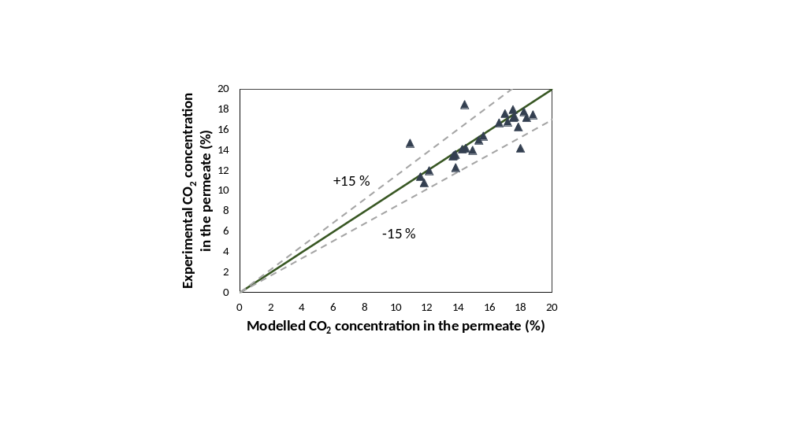
Figure 2: CO₂ capture model adjustment to experimental data for the CO₂ permeate concentration.
    - ERCO₂ pilot plant validation
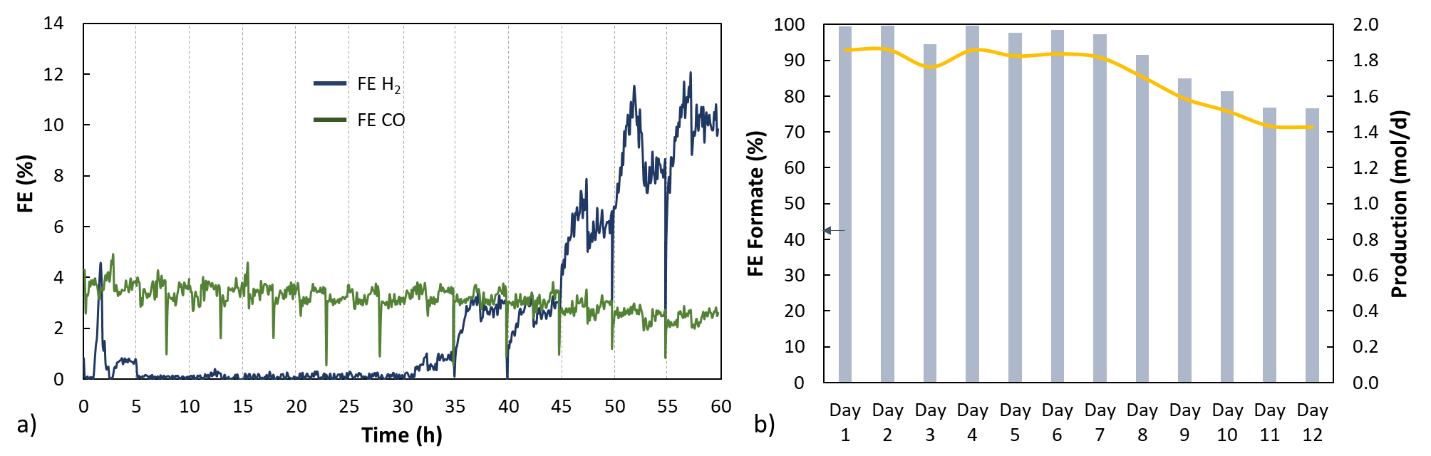
Experimental validation is carried out to assess the stability of the CO₂ electroreduction system using (BiO)₂CO₃ as the catalyst in the GDE. This material is selected for its enhanced durability under CO₂ electroreduction conditions, which mitigates previously observed degradation and extends stable cell operation (Abarca et al. 2025). The system is evaluated using pure CO₂ feed under identical operating conditions, with 5 hours of daily operation over several consecutive days, without disassembling the cell or replacing the electrode. As shown in Figure 3, the use of (BiO)₂CO₃ significantly improves the stability of the CO₂ electroreduction process. The FE toward H₂ remains below 10% throughout the 12 days of testing, while CO production stays within the 3–4% range. Meanwhile, the FE toward formate remains close to 100% during the initial days and gradually decreases to approximately 75% by day 12, due to the electrode degradation, which begins on day 8.
Overall, the average daily formate production reaches 1.7 mol, resulting in a cumulative production exceeding 20 mol, thus demonstrating a promising long‑term performance of the (BiO)₂CO₃‑based electrode incorporated in the 100 cm² electrolyzer prototype.

Figure 3: a) Evolution of FE toward H₂ and CO during experiments conducted over several consecutive days, and b) daily results for FE toward formate and formate production.
Data from several long‑term experiments are used to construct the training dataset for the digital twin, supporting its ability to predict and monitor plant behavior under real industrial operating conditions.
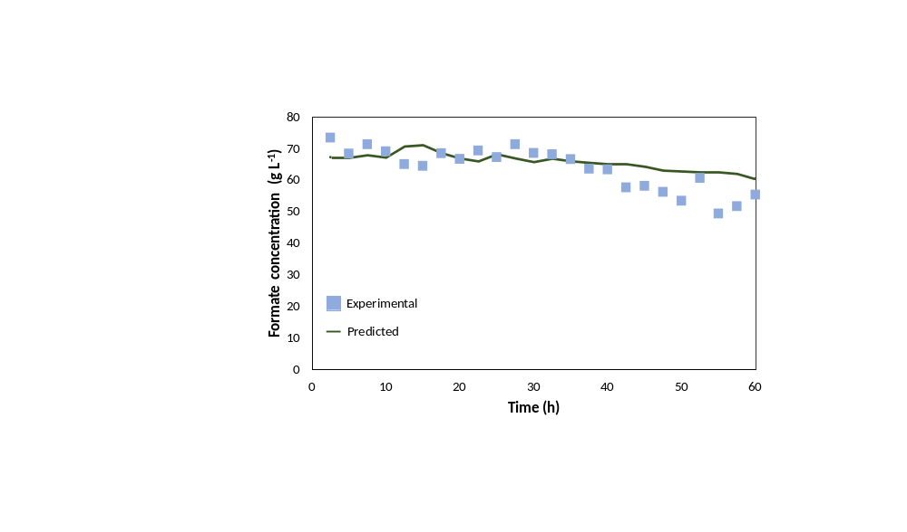
In this context, Figure 4 compares the experimentally measured formate concentrations, obtained at 2.5-hour intervals, with the corresponding values predicted by the digital twin over the same operating period. As shown, there is a good agreement between the experimental data and the model predictions during the initial stages of the experiment, indicating that the digital twin accurately captures the system behavior under stable operating conditions. However, as the experiment progresses, a slight discrepancy becomes apparent, with the model increasingly overestimating the formate concentration. This deviation is attributed to electrode deactivation phenomena, which are not currently incorporated into the model. Consequently, long-term experimental studies of this type are essential for generating the data required to characterize electrode degradation and quantify its impact on system performance. Incorporating these effects into the digital twin will improve its predictive capability and enable a more accurate estimation of the system’s long-term stability and operational lifetime.
Figure 4: ERCO₂ model adjustment to experimental data in terms of formate concentration.

    - CO₂ Capture and conversion integration
The first stage of the integration strategy is the conditioning of the industrial exhaust gases prior to conversion. For efficient ERCO₂ operation, the CO₂ concentration must be increased above 70–75%. As demonstrated in the experimental validation of membrane‑based capture, a single membrane stage only allows the CO₂ concentration to be increased from values around 10% up to approximately 20%, which is insufficient for direct utilization. Therefore, supported by the developed predictive model, it is determined that three capture stages using hollow‑fiber membrane modules, similar to those used at the laboratory scale, connected in series are required. Under optimal pressure and feed‑flow conditions, this configuration enables CO₂ concentrations of up to 95% to be achieved.
The second stage involves coupling the capture system with the conversion unit. Since the permeate stream exits the membrane system at near‑atmospheric pressure, a compressor is required to raise the pressure at the inlet of the utilization unit, as a slight overpressure is necessary for proper operation. The conversion stage is designed to process a CO₂ flow rate of 20 L min⁻¹, which poses a challenge in terms of electrolyzer design.
The scale-up of this technology presents several key challenges, particularly the integration of flue gas sources with CO₂ capture, and conversion units while ensuring stable gas flow rates, pressure control, and overall process reliability. For CO₂ electroreduction systems, one of the main challenges at the demonstration stage is improving electrode durability to enable stable and continuous operation over extended periods, ideally for hundreds of hours. Once this challenge is addressed, additional issues become increasingly important, including the high energy demand of the process, efficient electrolyte management, and the handling and recycling of process streams such as unconverted CO₂. Evaluating and mitigating these challenges during the demonstration phase is essential to reduce technical risks and facilitate the successful industrial deployment of the technology.
  - Conclusions
In this work, the operation of two laboratory‑scale pilot plants for CO₂ capture and utilization is experimentally validated. The single-membrane stage achieved CO₂ enrichment up to 18.5%, while the ERCO₂-to-formate system demonstrated high stability, with an average daily production of 1.7 mol and maintained FEs near 100%. Based on these experimental data, two predictive mathematical models were developed, showing high reliability. These models are integrated into a digital twin to monitor and predict the behavior of the overall CO₂ recycling plant. Insights from these tests, such as the requirement of three membrane stages to reach 95% CO₂ for optimal conversion, have guided critical design decisions for the overall system, leveraging the digital twin to support its effective implementation and reliable operation. This methodology facilitates the optimization of CO₂ recycling solutions adapted to the specific requirements and constraints of different industrial sectors.
Acknowledgements
The authors acknowledge financial support through project PDC2025-165116-I00 (MICIU/AEI/10.13039/501100011033). The present work is related to CAPTUS Project, this project has received funding from the European Union’s Horizon Europe research and innovation programme under grant agreement No 101118265. J.A. Abarca acknowledges the FPI grant PRE2021-097200 received from the Spanish Ministry of Science and Innovation.
  - References
Abarca J.A., Warmuth L., Rieder A., Dutta A., Vesztergom S., Broekmann P., Irabien A., Díaz‑Sainz G., 2025, GDE Stability in CO₂ Electroreduction to Formate: The Role of Ionomer Type and Loading, ACS Catalysis, 15, 8753–8767.
Abarca J.A., Díaz‑Sainz G., Irabien A., 2026, CO₂ electroreduction to formate: Advancing toward scalable technologies, ACS Applied Energy Materials, 9, 2041–2049.
Han Y., Ho W.S.W., 2021, Polymeric membranes for CO₂ separation and capture, Journal of Membrane Science, 628, 119244.
He X., Fu C., Hägg M.B., 2015, Membrane system design and process feasibility analysis for CO₂ capture from flue gas with a fixed‑site‑carrier membrane, Chemical Engineering Journal, 268, 1–9.
Mikulčić H., Skov I.R., Dominković D.F., Wan Alwi S.R., Manan Z.A., Tan R., Duić N., Hidayah Mohamad S.N., Wang X., 2019, Flexible carbon capture and utilization technologies in future energy systems and the utilization pathways of captured CO₂, Renewable and Sustainable Energy Reviews, 114, 109338.
Rafiee A., Rajab Khalilpour K., Milani D., Panahi M., 2018, Trends in CO₂ conversion and utilization: A review from process systems perspective, Journal of Environmental Chemical Engineering, 6, 5771–5794.
Rumayor M., Domínguez‑Ramos A., Pérez P., Irabien A., 2019, A techno‑economic evaluation approach to the electrochemical reduction of CO₂ for formic acid manufacture, Journal of CO₂ Utilization, 34, 490–499.

